
Courgette and cheese muffins

Ingredients | Equipment
1 small courgette  100g cheddar cheese  225g self raising flour  50ml oil  175ml semi-skimmed milk  1 egg  Black pepper | 12 muffin cases, muffin tin, chopping board, knife, grater, measuring jug, mixing bowl, wooden spoon, 2 spoons, cooling rack.
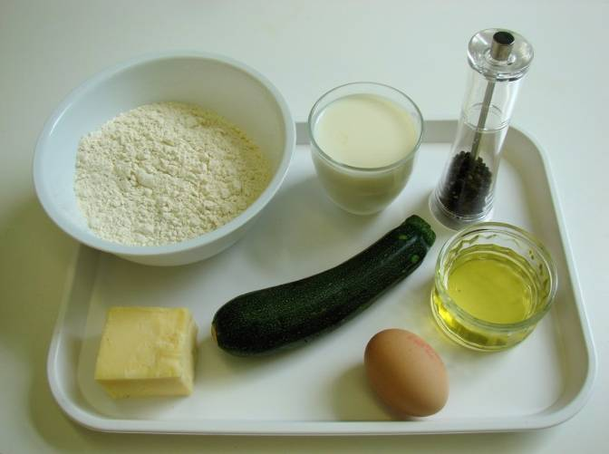 | 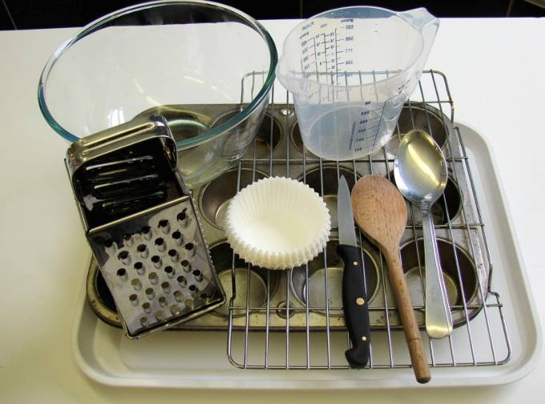
Method
1. Preheat oven to 200°C or gas mark 6. | 2. Place the muffin cases in the muffin tin.
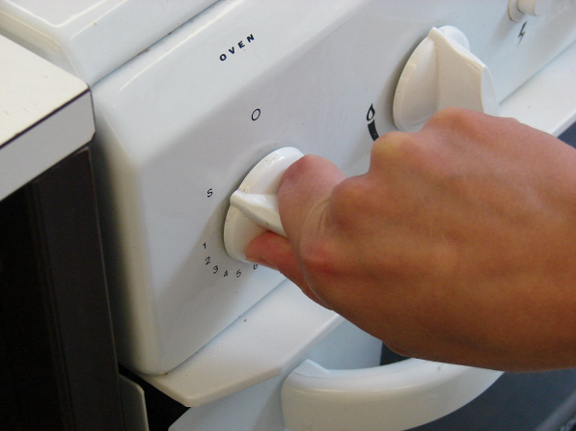 | 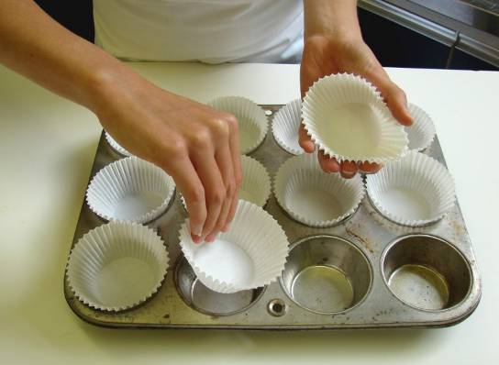
3. Cut the ends of the courgette. | 4. Grate the courgette and cheese.
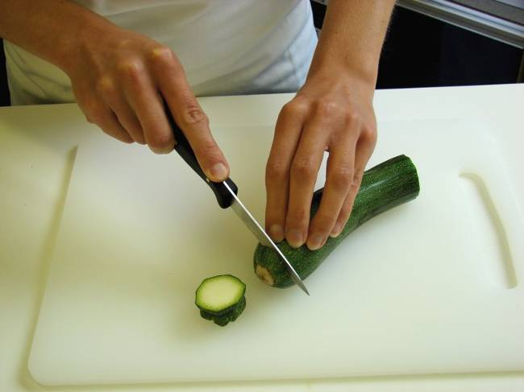 | 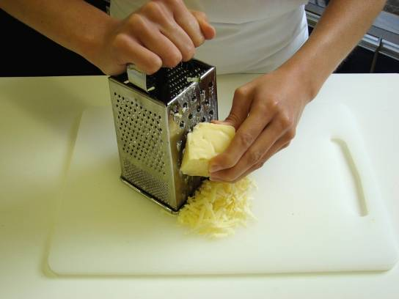
5. Mix all the ingredients together to form a smooth batter. | 6. Mix all the ingredients together to form a smooth batter.
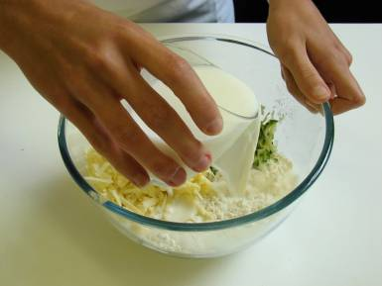 | 
7. Divide the mixture equally between the muffin cases using 2 spoons. | 8. Bake for 20 minutes, until golden.
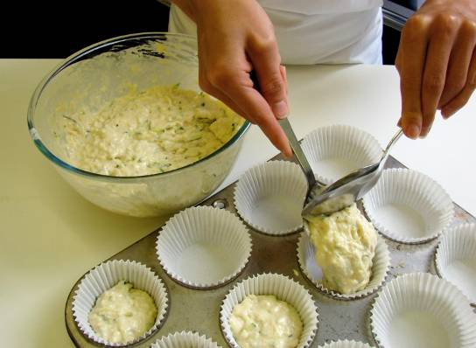 | 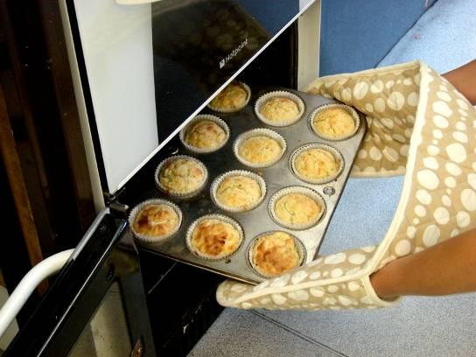
9. Allow to cool on a cooling rack.



