

Mini Carrot Cakes

Ingredients | Equipment
150g margarine  250g carrots  200g sugar  200g flour  2 x 5ml cinnamon  2 x 5ml baking powder  2 large eggs  125g sultanas  50g nuts | Chopping board, knife, vegetable peeler, grater, measuring spoons, weighing scales, small bowl, mixing bowl , wooden spoon, sieve, muffin tray, 12 muffin cases, 2 large spoons, fork.
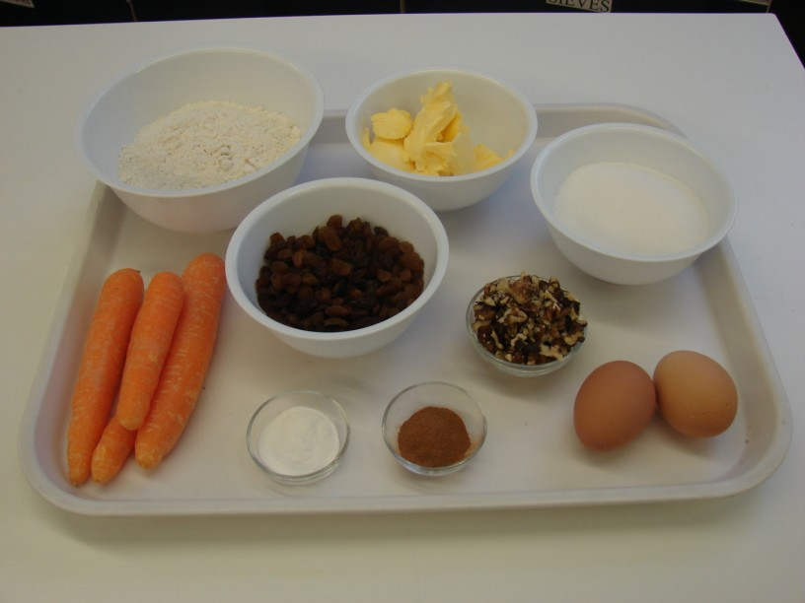 | 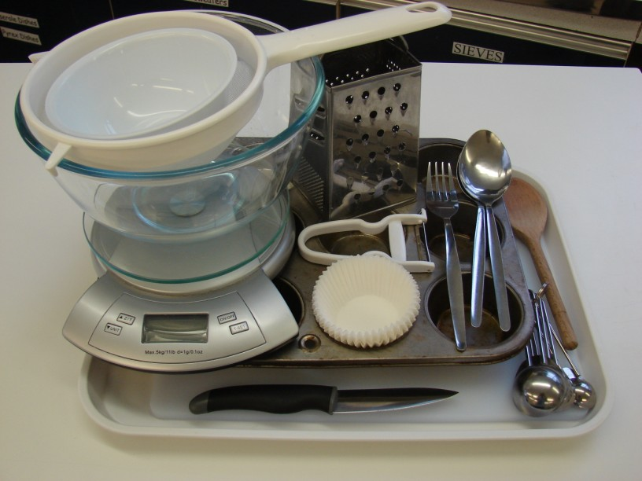
Method
- Preheat the oven to 200ºC or gas mark 6. | - Melt the margarine in the microwave.
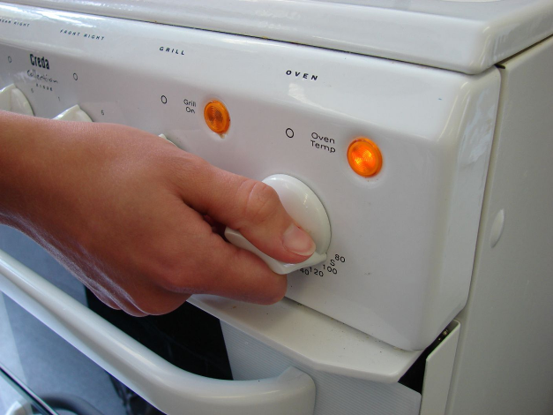 | 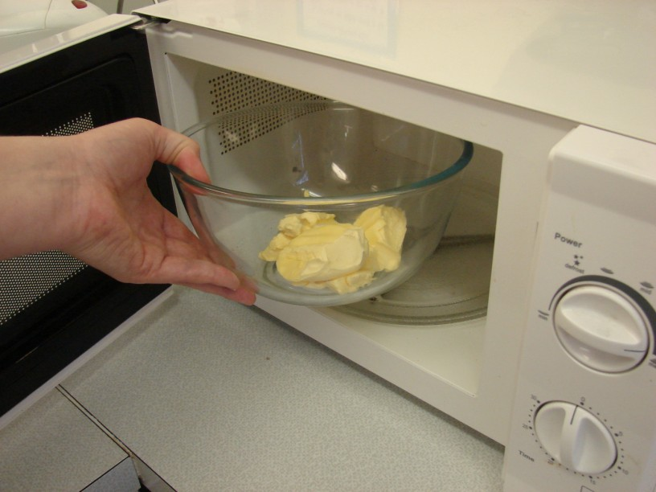
- Top and tail, and then peel and grate the carrots. | - Combine the carrots, sugar and margarine in the mining bowl.
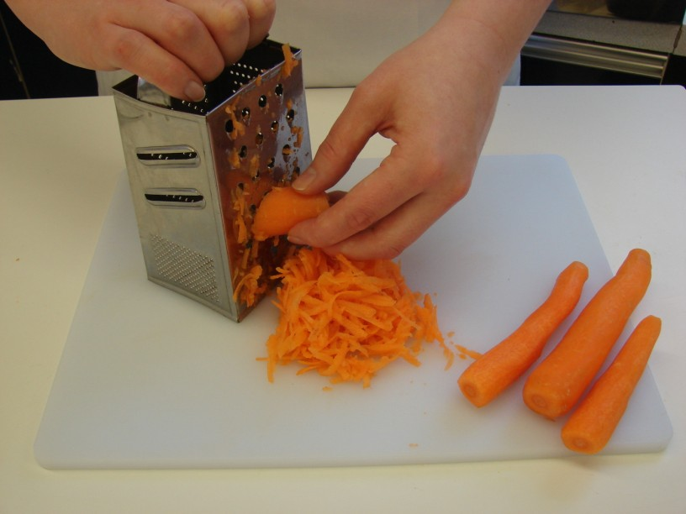 | 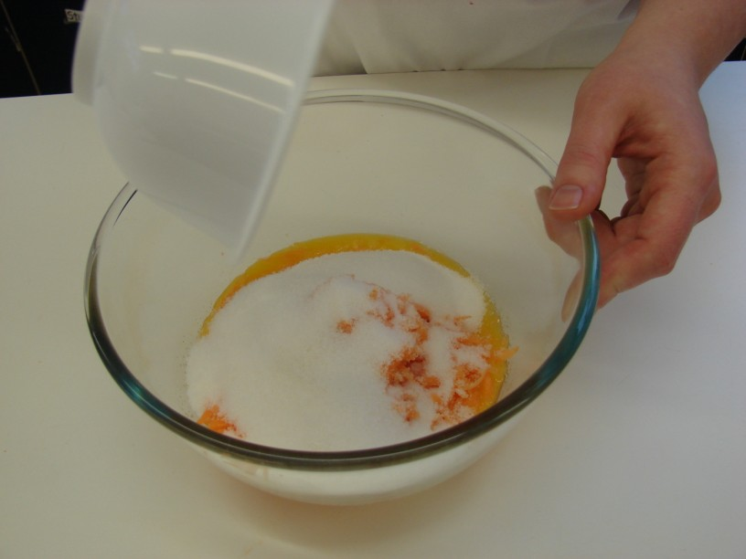
- Sift in the flour, cinnamon and baking powder. | - Beat the eggs in a small bowl, and then add to the mixture.
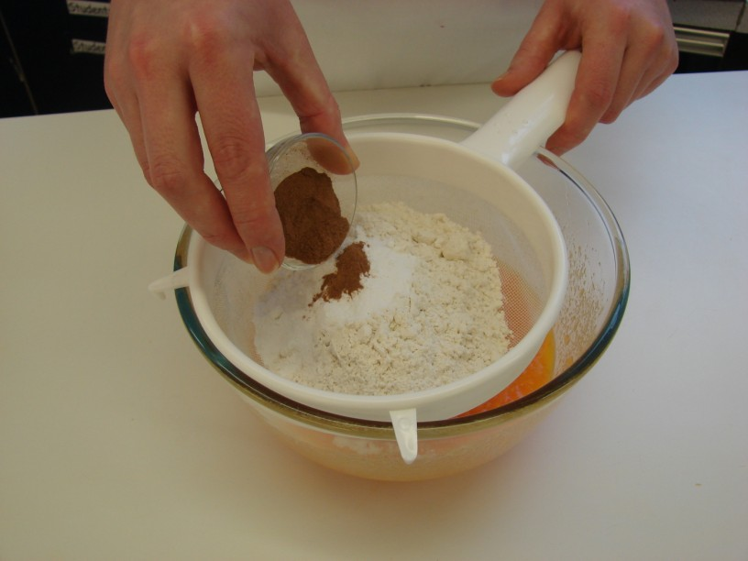 | 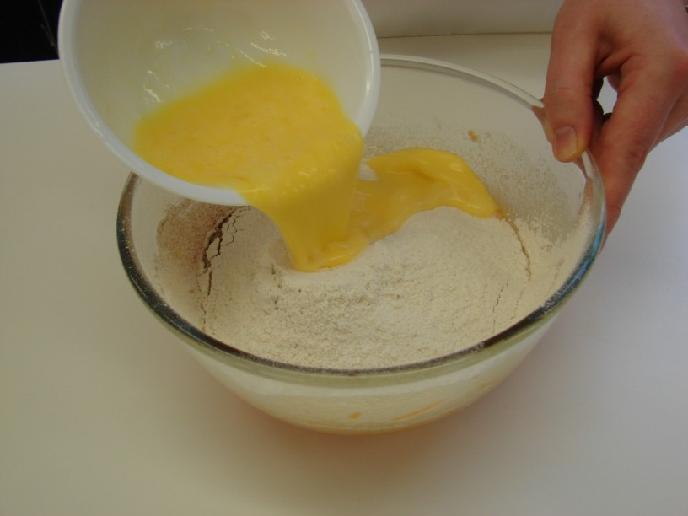
- Mix in the sultanas and nuts. | - Divide the mixture equally between the muffin cases, using the two metal spoons.
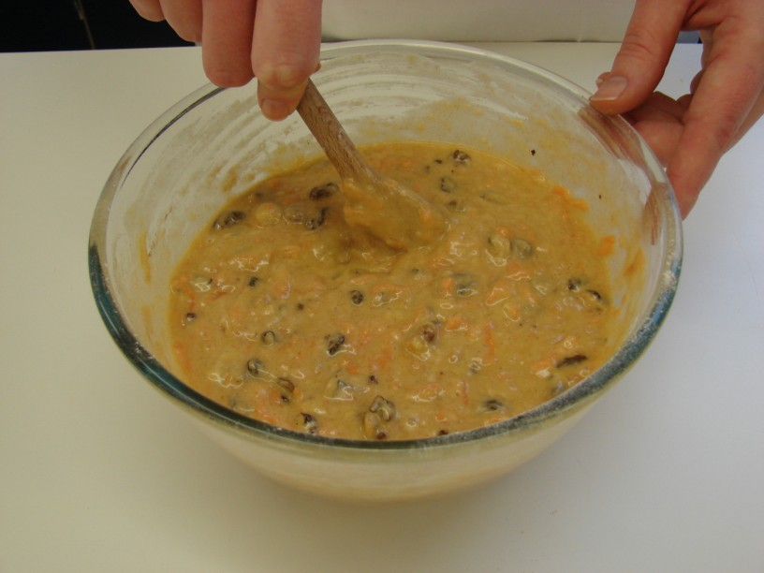 | 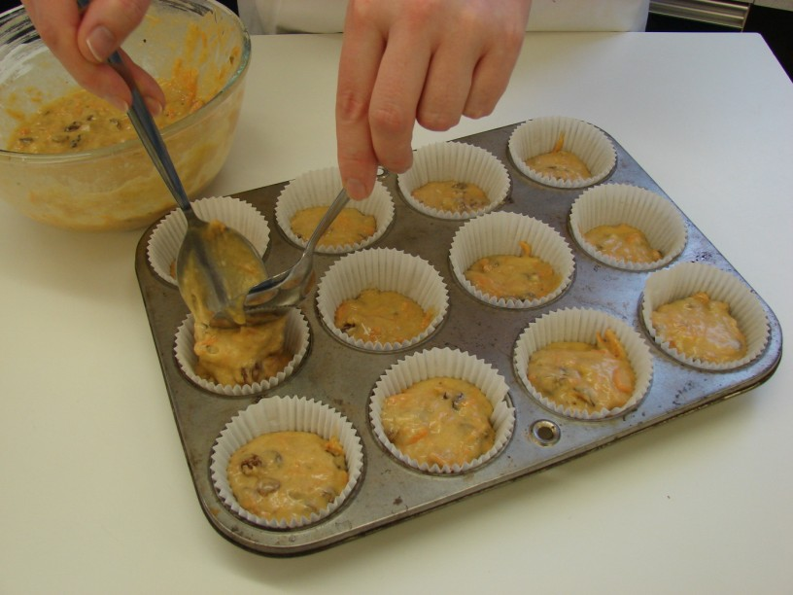
- Bake for 20 minutes.

