

Layered Pasta Salad

Ingredients | Equipment
100g pasta shapes  1 carrot  100g cooked sliced chicken  1 baby gem lettuce  1 tomato  ¼ cucumber  2 x15ml spoons low fat dressing | Weighing scales, saucepan, chopping board, knife, vegetable peeler, grater, measuring spoons, spoon, colander, serving dish.
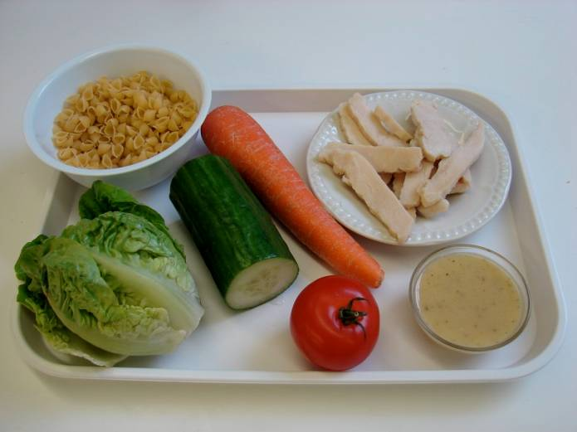 | 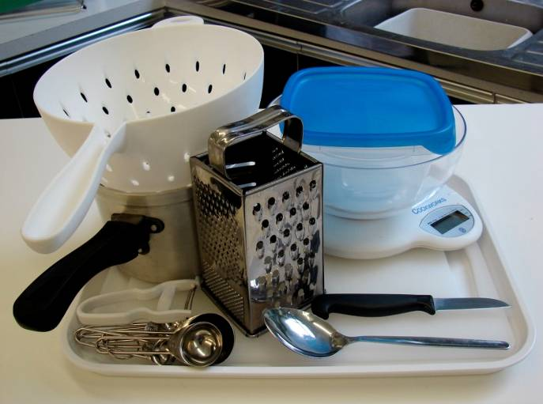
Method
1. Bring a small saucepan of water to the boil, and then add the pasta. Simmer for about 8 – 10 minutes (check the packet instructions). | 2. While the pasta is cooking, prepare the other ingredients:  - shred the lettuce;
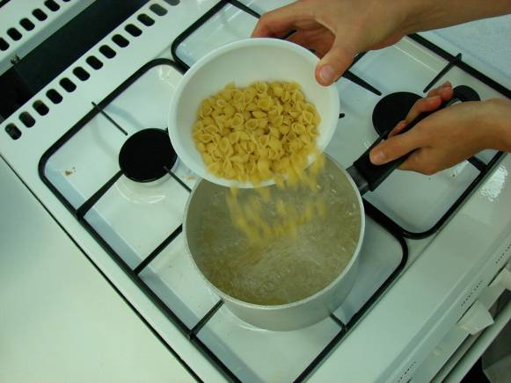 | 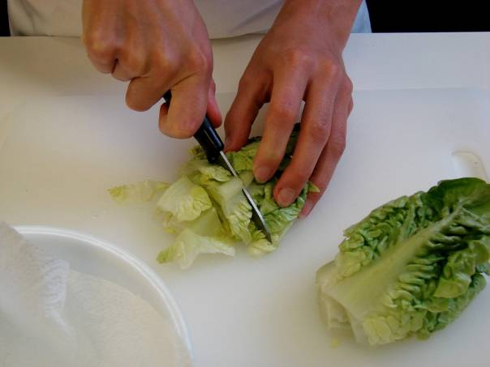
- slice the tomato; | - chop the cucumber into small chunks;
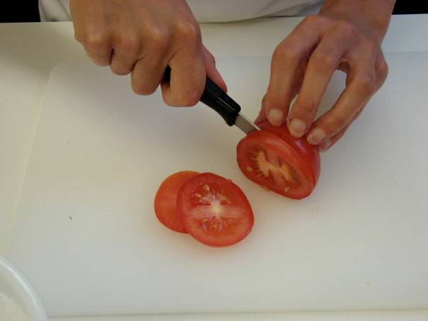 | 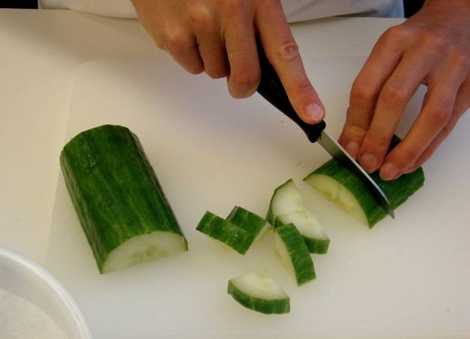
- peel and grate the carrot; | 3. Drain the boiling hot water away from the pasta into a colander in the sink. Cool the pasta by rising it under a cold tap for a few moments. Drain well.
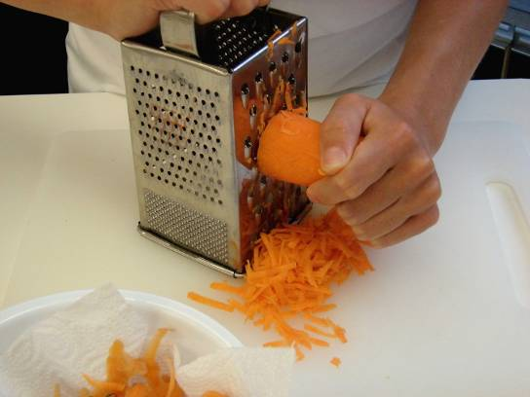 | 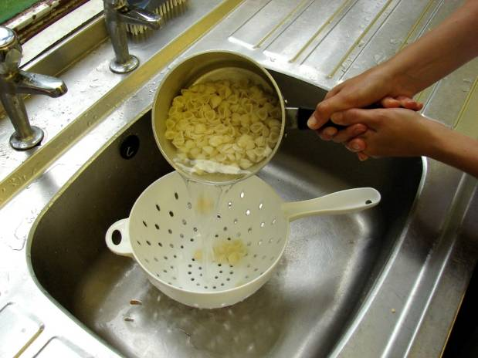
4. Place the pasta in the serving dish and stir in 1 x 15ml spoon of dressing. | 5. Assemble the remaining ingredients over the pasta in layers.
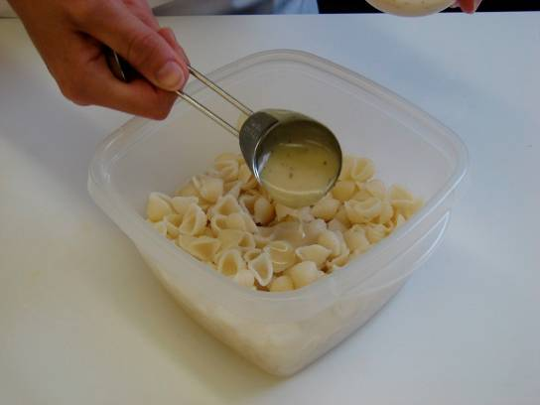 | 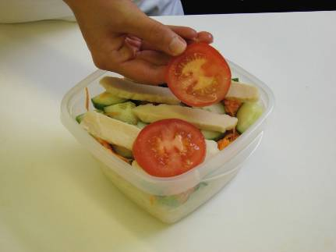
6. Lastly, drizzle over the remaining dressing.

